**Embedded System Challenge – Key Pad Lock Security System**

Challenge:

Create a system that would be used for locking and unlocking doors or containers. You will be provided with:

* Arduino Nano – this is the main microcontroller for the system
* Button Matrix Keypad – this is the user input for the system

The programming language for this challenge is the Arduino Language, which is based upon C.

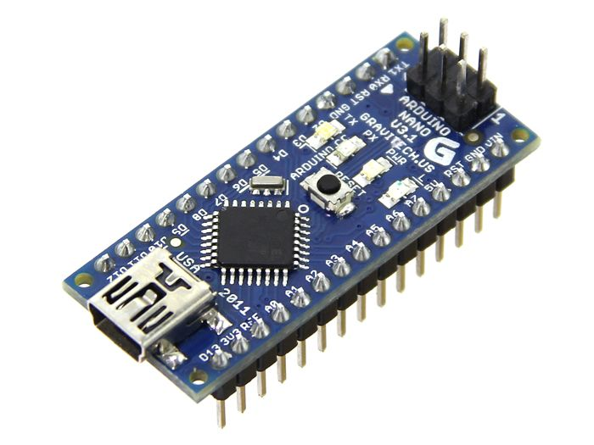

The system should be capable of unlocking or locking when the user inputs the correct button sequence, this is the bare minimum functionality required but add as many features as you can to make your team’s system stand out! Whilst this is considered a lock system you do not have to create any real locking mechanism, just toggling a pin on the board is enough.

Goals:

* Lock/Unlock with passcode
* Provide a means for the user to see if the system is locked or unlocked (outputs e.g. LED indicators)

Extension Goals:

* Limited attempts at entering passcode
* Add the ability for the user to change the passcode on the fly (passcode not hardcoded)
* Use serial console as a display for the system (shows if locked, unlocked etc)
* Create a PC user interface for the system, this could be done in whatever language you like – I would recommend Python with pySerial library for communication over USB serial.